**Pirate Game**

By: Nikhil Shende, Jamie Caille, and Daniel Papadopoulos

Introduction:

Yarr mateys, welcome to ye olde Pirate Game. We hope ye have a swashbuckling time plundering booty and sailing the seven seas.

**Table of Contents**

1. **Start-up**
2. **Main Menu**
   1. **Start**
   2. **Settings**
   3. **Credits**
   4. **Close**
3. **Objective of the Game**
4. **Player Movement**
5. **Combat**
6. **Shop/Gold System**
7. **Termination**
8. **High Score**
9. **Start-up**

Upon starting the program, the main menu will be shown.

1. **Main Menu**

The main menu is navigating by the arrow keys. To select an option, press right on the arrow key to navigate to the sub-menu on the right, press up and down to navigate between sub-options, then press enter on the option you would like to choose.

* 1. **Start**

This option starts the game.

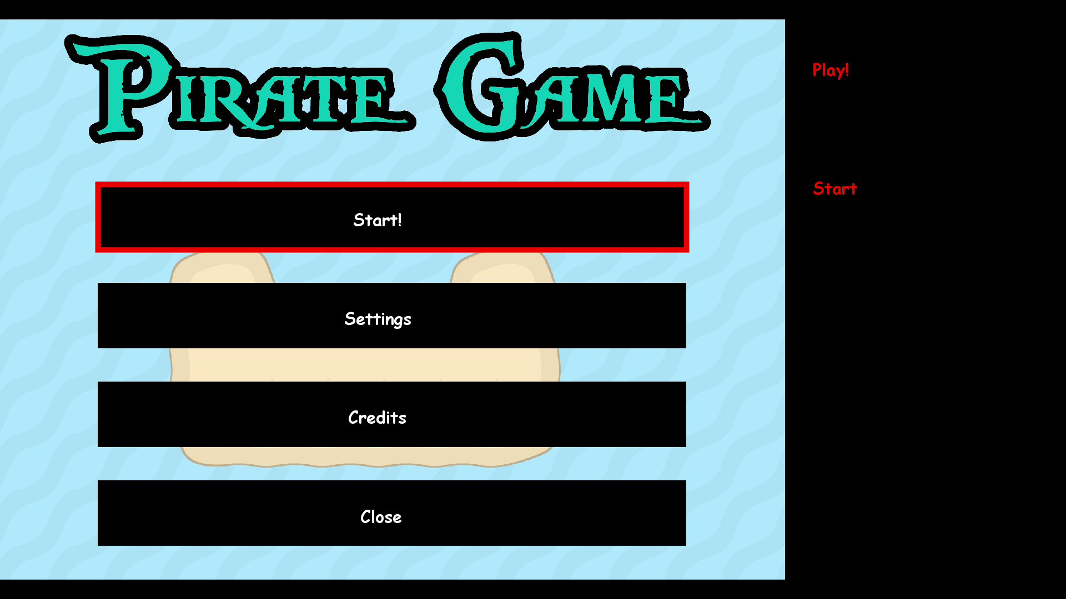

* 1. **Settings**

This option allows you to change your ship’s sail colour.

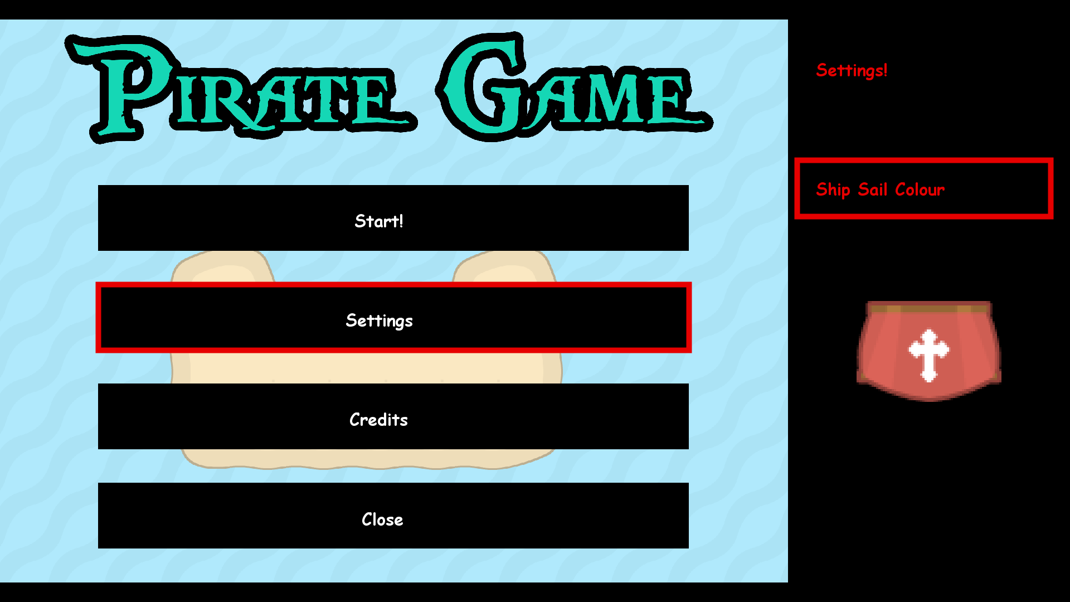

* 1. **Credits**

This option allows you to view the credits, and see the names of the people behind this game.

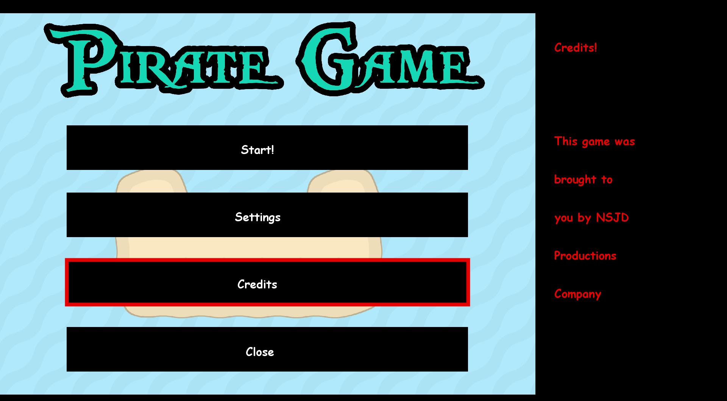

* 1. **Close**

This option exits the game. If you do not wish to exit, press continue.

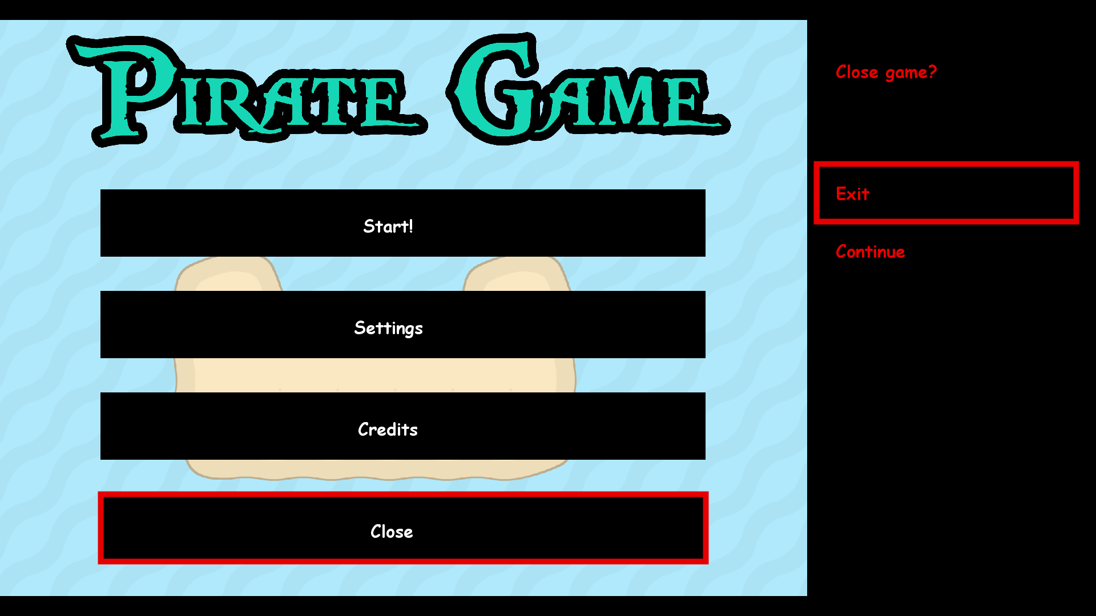

1. **Objective of the Game**

When you start the game, you are put into a vast ocean, where you are free to explore throughout its entirety. The beginning area contains a shop. For more information on the shop, go to **(VI)**.

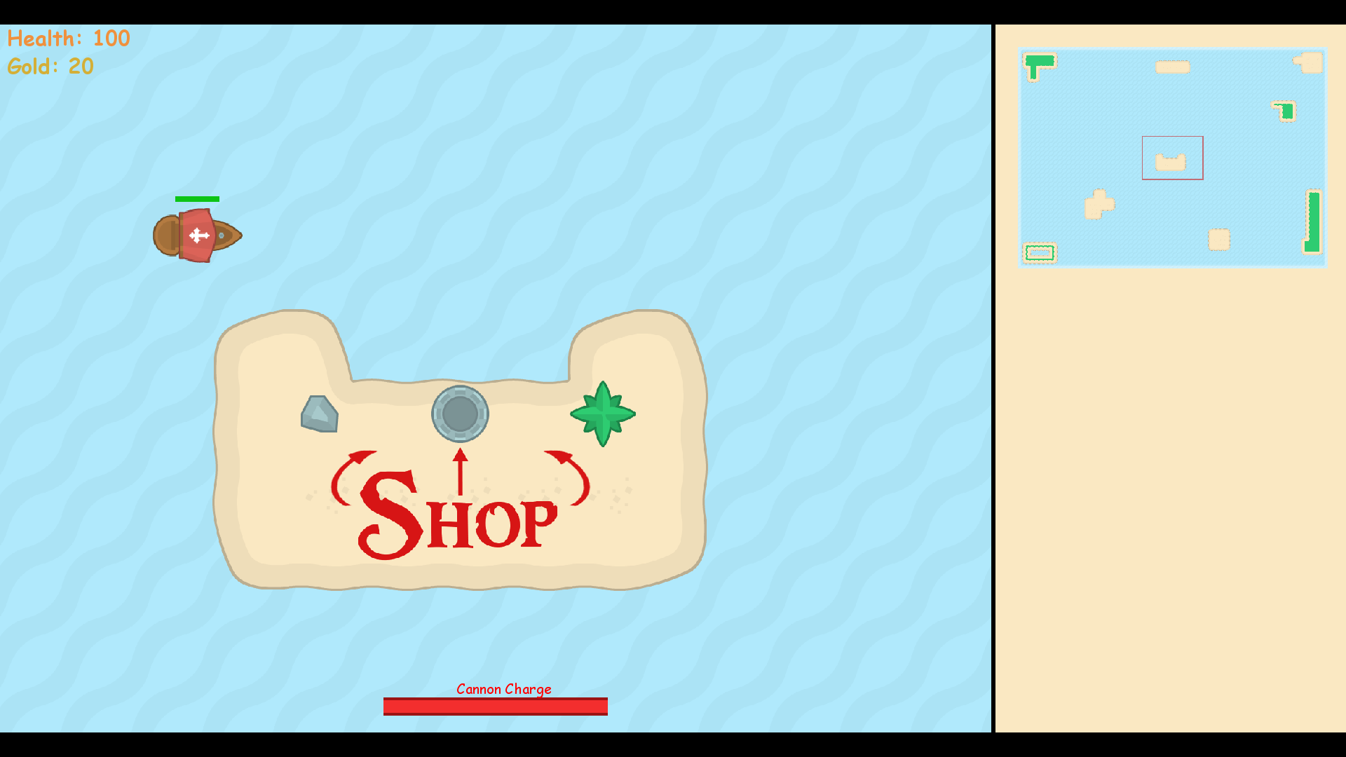

You may encounter enemy ships or fortresses. Information on how to defeat them is in **(V)**.

Enemy Ship pictured below:

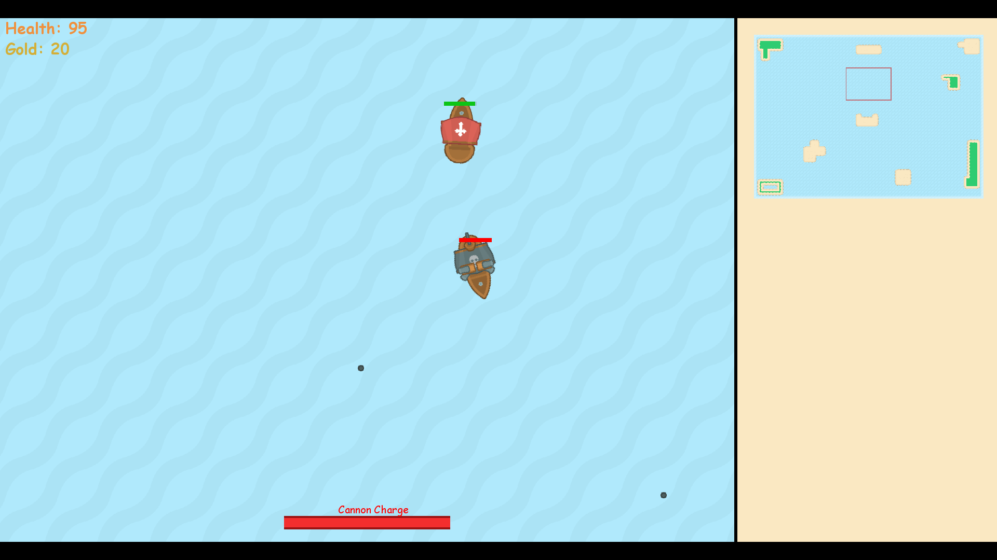

Fortress pictured below:

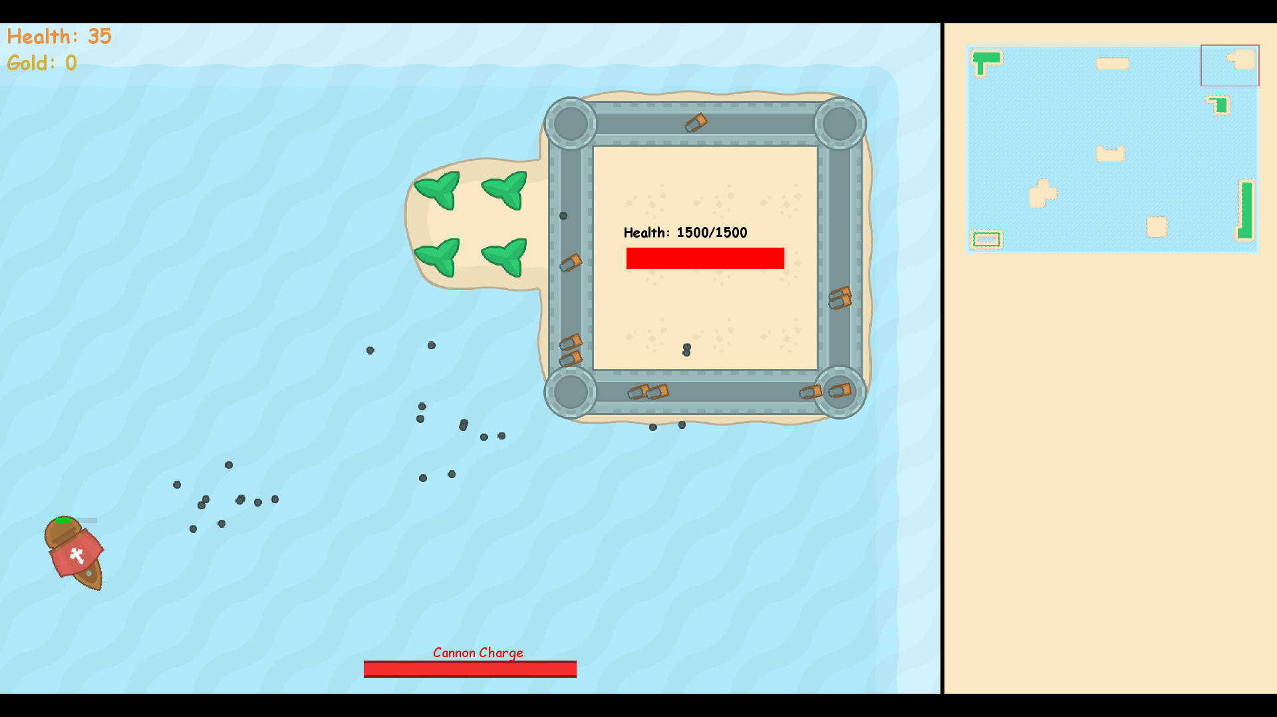

1. **Player Movement**

The player character is moved using the ‘w’, ‘a’, ‘s’, and ‘d’ keys. The ‘w’ and ‘s’ keys move the player forward and backward, respectively, and the ‘a’ and ‘d’ keys turn the player left and right, respectively. The player can only turn while moving. It is important to understand how movement works before venturing off into the vast ocean.

1. **Combat**

Combat consists of firing cannonballs at enemies, whilst dodging enemy cannonballs. You can fire cannonballs by pressing SPACE. Keep an eye the Cannon Charge meter, as you are unable to fire a cannonball if the meter is not full.

When you defeat an enemy ship, you are awarded 5 gold, along with 30 health. When you defeat an enemy fortress, you are awarded gold proportional to the fortresses health, and your health is fully replenished.

Ships are relatively easy to defeat while fortresses are difficult. Some fortresses are more difficult than others.

1. **Shop/Gold System**

When you begin the game, the first screen you see contains an Island that contains the shop. You can use gold that you have acquired to upgrade your ships attributes at the shop. You acquire gold by defeating ships and fortresses. You can upgrade your ship’s movement speed, cannon recharge rate, cannon damage, and you can add 2 more cannons. When you have upgraded the attribute fully, there will be a sold out sign.

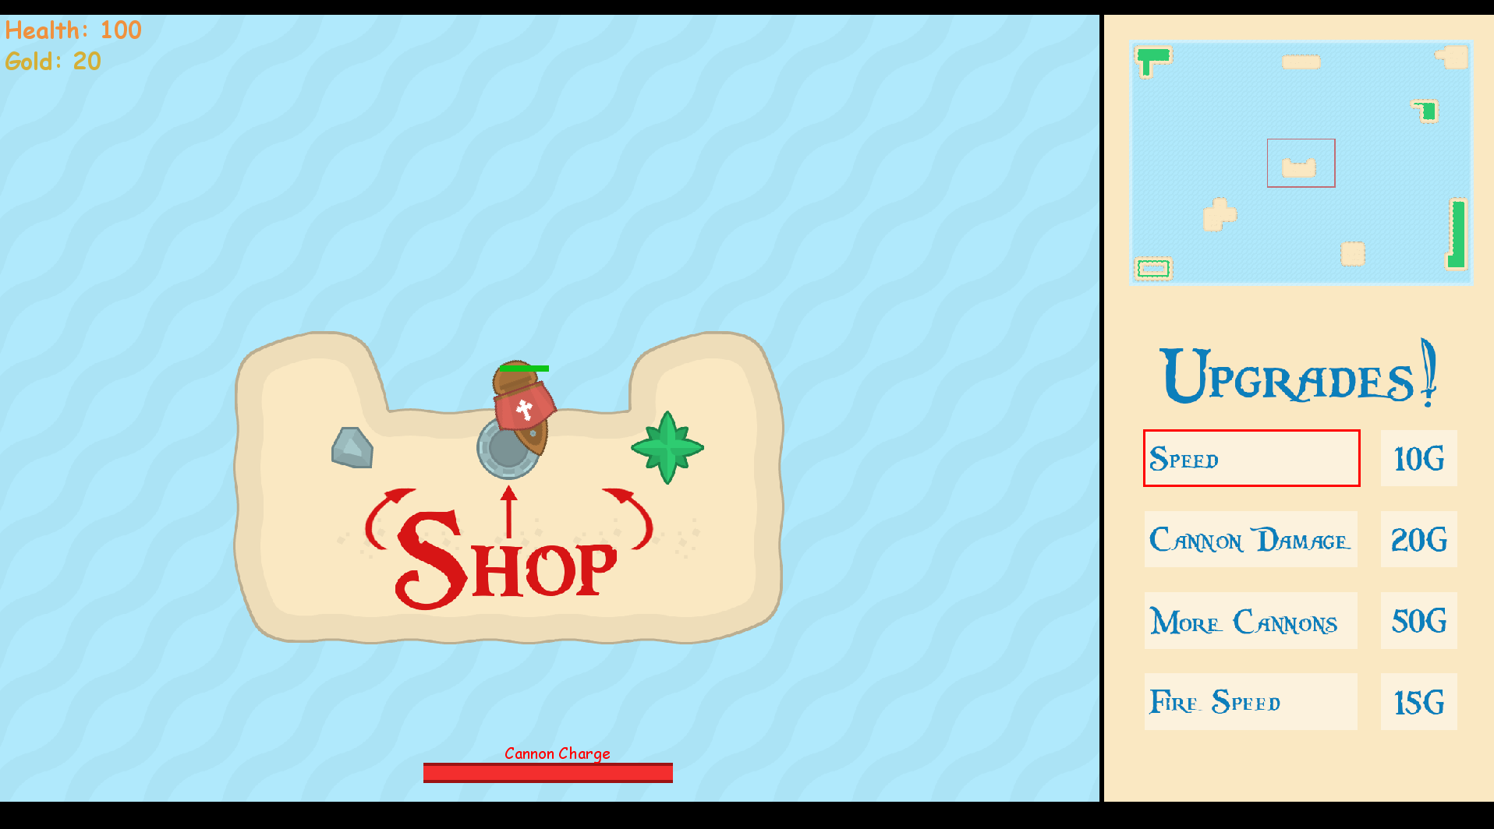

1. **Termination**

When you press ESCAPE during the game, you will be brought to the close section in the menu **(II,d)**. If exit is selected, then the program will run the High Score functions **(VII)** before closing itself.

1. **High Score**

If your score happens to be in the top 5, then the game will ask you to input your name.

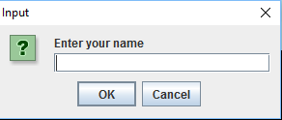

Then, regardless of your score the game will display the top 5 scores, along with the names of the players who achieved those scores.

